Project Design Phase-II

Technology Stack (Architecture & Stack)
Date | 29 September 2026
Team ID | 6ab1d50c92b876d9664094bc
Project Name | Auto Ticket Classification Using Flow Designer
Maximum Marks | 4 Marks

Technical Architecture
Proposed rule-based ServiceNow solution: when an incident is created, Flow Designer evaluates configured conditions and updates classification and assignment fields. Unmatched tickets remain available for manual triage. The solution uses native ServiceNow features; no machine-learning model or third-party API is required for the proposed scope.
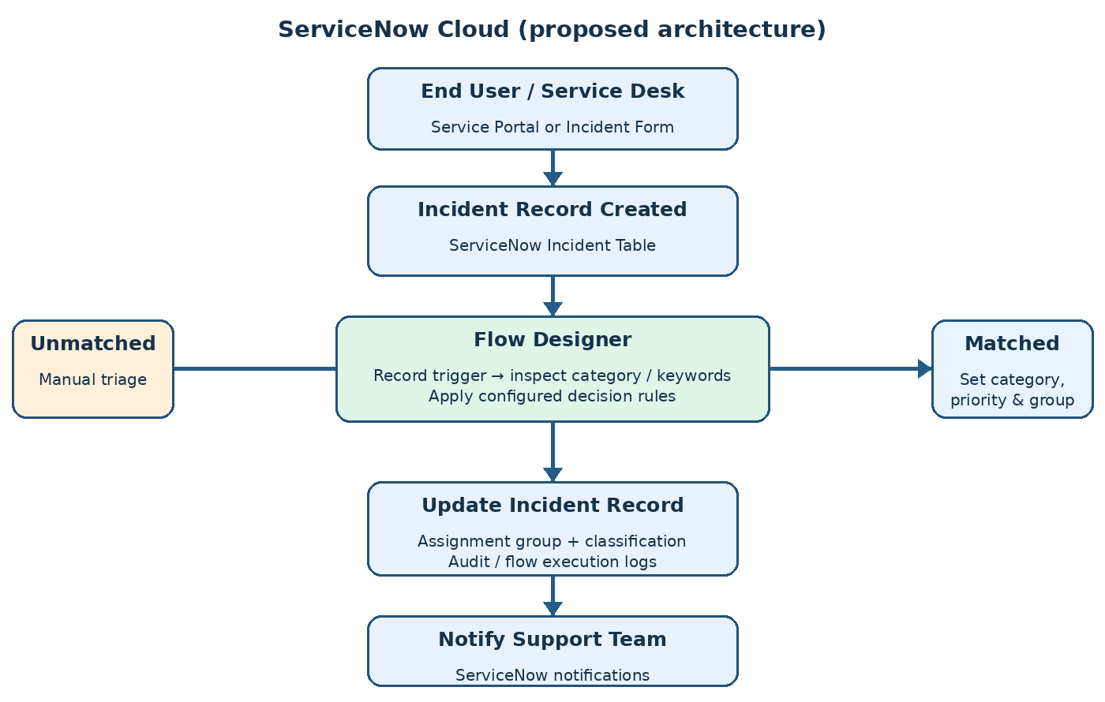
Infrastructure: ServiceNow-hosted cloud instance. External interfaces: none required in the proposed scope. Storage: native Incident records and platform flow execution logs. ML model: not applicable (rule-based classification).

Table-1: Components & Technologies
S.No | Component | Description | Technology
1 | User Interface | Create and view incidents; review assigned tickets | ServiceNow Service Portal / Incident Form
2 | Application Logic-1 | Trigger classification on incident creation | ServiceNow Flow Designer – Record Trigger
3 | Application Logic-2 | Evaluate category, subcategory, description and keywords | Flow Designer conditions / decision logic
4 | Application Logic-3 | Update classification, priority and assignment group; notify team | Flow Designer Update Record / Notification
5 | Database | Store incidents, categories and assignment groups | ServiceNow native tables (Incident, Group)
6 | Cloud Database | Platform-managed persistent storage | ServiceNow cloud data layer
7 | File Storage | Optional ticket attachments | ServiceNow attachment storage
8 | External API-1 | Not needed for basic workflow | Not applicable
9 | External API-2 | Optional future integration with other ticket sources | ServiceNow REST API (optional)
10 | Machine Learning Model | Rule-based solution; model not used | Not applicable
11 | Infrastructure (Server / Cloud) | Hosted application; no separate local server required | ServiceNow cloud instance

Table-2: Application Characteristics
S.No | Characteristics | Description | Technology
1 | Open-Source Frameworks | No separate open-source framework is required for the core workflow. | Native ServiceNow platform
2 | Security Implementations | Role-based access for incident users and admins; access control on records. | ServiceNow roles and ACLs
3 | Scalable Architecture | Cloud-hosted workflow uses platform-managed infrastructure; review flow limits for larger volumes. | ServiceNow cloud + Flow Designer
4 | Availability | Availability depends on the selected ServiceNow subscription and instance operations. | ServiceNow managed hosting
5 | Performance | Keep conditions specific, avoid unnecessary actions, and monitor flow execution. | Flow Designer execution monitoring
Note: This is a proposed architecture and technology stack, not a claim that the workflow has already been deployed or tested.

